電器規格  使用電源：請參閱儀器背面電壓規格。(AC100V~240V 50/60 Hz)  顯示器：0.56” LED， 3 ¹/₂ 位數。  輸入阻抗：10¹² 歐姆。  耗電：大約 2 瓦。  控制信號規格：Normal Open.  控制啟動指示：LED 亮燈指示。  測量範圍：pH 0 ~ pH 14。  外部校正：pH7 (CAL.) 和 pH4 / pH10 (SLOPE) 兩點校正。  設定控制範圍：pH 3.5 ~ pH 10.5。  解析度（讀值）：0.01 pH。  精確度（校正後誤差）：±(0.01 pH +2位)。  控制選擇： "HI-A" 測量值高於設定值時，啟動控制信號。  "LO-A" 測量值低於設定值時，啟動控制信號。  外觀尺寸：150 ×85 ×40 mm (5.9 × 3.4 × 1.6 inch)   pH 電極置於水中不可超過電極帽高度。  電極輸入插座除了 pH 電極外，不可插入其它插頭。  控制器使用時請盡量遠離電子式安定器電燈，及不要使  用同一電源插座，避免干擾本儀器。  3 2011-PH-2201C |  | pH 監控器使用說明書  (可選擇高/低啟動控制)  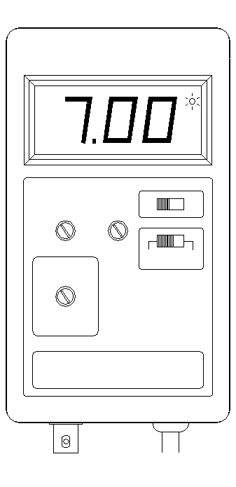  使用本pH監控器前，  請詳細閱讀本說明書，正確使用及確保測試值的準確度
  經銷商

各部名稱說明  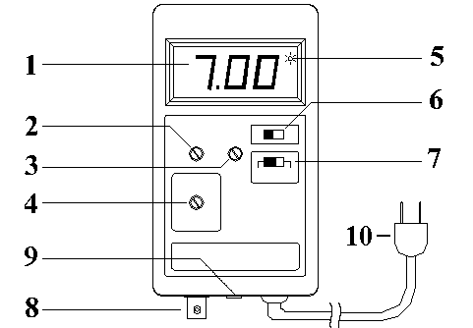  操作說明  - 依電壓規格指示接上電源。選擇高於設定值啟動控制電源者，請將 HI/LO 開關切於" HI-A " 位置。若選擇低於設定值啟動控制電源者請將 HI/LO 開關切於" LO-A "位置。  2) 將 pH 電極裝入 pH 輸入端 (BNC接頭插入後，右轉到底)。  3) 將選擇開關位置切到 " pH " 位置。  4) 將 pH 電極以蒸餾水稍做清洗擦乾後放入 pH7 校正液中，等待數秒鐘待顯示值穩定後，調整 " pH7 " 旋鈕，使顯示的數值為 7.00。  5) 將 pH 電極從 pH7 校正液中取出以蒸餾水稍作清洗擦乾後，將 pH 電極放入 pH4 校正液中，等待數秒鐘待顯示值穩定後，調整 " pH4 " 旋鈕，使顯示的值為 4.00。  （此步驟 4、5 為新電極使用前必須的校正步驟）  6) 完成校正後，可將電極放入待測水中，將pH/SET功能開關位置切到 " SET " 設定位置。(此時控制信號 自動關閉)  7) 利用小型 "─" 字起子調整 SET 的旋鈕，使顯示的數字到達到所需要設定的 pH 值。(若開關置於" HI-A "，測試值高於設定值時會啟動控制信號。若開關置於" LO-A "，測試值低於設定值時會啟動控制信號)，設定完後請將開關切回 " pH " 測量位置。  1 |  | 清潔保養  1) pH 電極置於水中不可超過電極帽高度，且定期(1 ~ 2星期)以軟 毛牙刷輕刷清洗，不用時，電極請置於有保存液之封套內，若有結晶乃屬正常現象。擦拭儀器本體時，應避免水濺入內部，造成損壞。  2) pH 測試值，應待穩定平衡後，所讀出的值才是正確值。  3) pH 電極為一精密之玻璃製品，請勿敲擊。  4) pH 電極請勿用手及布類及酒精擦拭。  備註  為保護控制的設備不受連續頻繁開關動作而損壞，設有延遲啟動功能，控制點會有高於設定值一些(0.03~0.05pH)才動作，且低於設定值一些(0.03~0.05pH)才關閉的保護狀態(設定HI啟動狀態下)。  為什麼要測pH值  pH值代表水質呈現酸或鹼性的狀態 (pH值等於7為中性，pH值大於7為鹼性，pH值小於7為酸性)，大部分的觀賞魚都能適應生活在pH值＝7左右的中性水質，但許多魚種有特別的水質偏好。  例如：  pH＜7的魚種: 如七彩神仙，亞馬遜燈科魚等，喜好pH＝6.0到6.5的水質。  pH＞7的魚種: 如海水魚喜好pH＝8.4的水質，非洲慈鯛喜好pH7.5到8.0的水質。  ※ 所以對的pH值，才能把魚養對！  水質過酸時怎麼辦  應該調升水中的pH值，常見調整方法可以採用：  使用珊瑚砂底床，添加pH或KH、GH調高液(粉)劑或錠片，使用陰離子交換樹脂等方法。  水質過鹼時怎麼辦  應該調降水中的pH值，常見調整方法可以採用：  使用弱酸性底土底床，增加 RO(逆滲透)水使用比例，使用陽離子交換樹脂，添加pH調低液(粉)等方法。  2
  1) pH 顯示器 | 6) pH/SET 測量/設定 開關
  2) pH7 校正鈕 | 7) HI/LO 高/低 啟動選擇開關
  3) pH4 校正鈕 | 8) pH 電極 BNC 接頭
  4) 設定值調整鈕 | 9) 3.5mm 控制輸出座 (Normal Open)
  5) 啟動控制指示燈 | 10) 電源插頭

GENERAL SPECIFICATION  Power Supply：AC100V - AC240V  Measurement：0 to 14 pH  Resolution：0.01 pH  Accuracy at 25°C：±(0.1%+ 2 digits) after calibrating  Impedance：1012 ohms  Set Range：3.5 to 10.5 pH  Calibration Knob：External pH7 (CAL.) and pH4 / pH10(SLOPE)  Relay Contact：5A for 240VAC  Control Output Voltage：Same as plug in AC voltage  Display：0.56" LED, 3 ¹/₂ digits  Operating Temperature：0 to 50°C (32 to 122°F)  Operating Humidity：Max. 90%  Power Consumption：Approx. 2 watts  Dimension：150 x 85 x 40 mm (5.9 x 3.4 x 1.6 inch)  Standard Accessories : Instruction Manual, Adjustment Sticker, Instrument Holder, pH4, pH7 calibrating buffer each one.  pH electrode input BNC terminal can only connect with pH electrode, it is not allowed to connect with any other electrode.  3 2011-PH-2201C |  | OPERATION MANUAL  DIGITAL pH CONTROLLER  (WITH HI/LO ACTION OPTIONAL)  Please read the attached instructions carefully before use
  AFTER SERVICE CENTER

FRONT PANEL DESCRIPTION  OPERATING (CALIBRATION)  1) Connecting AC power supply.  2) Connecting the pH electrode into the pH input terminal socket.  3) Turn the pH/SET switch to "pH" position.  4) Put the pH electrode into the standard buffer solution pH7.00. Waiting a few seconds for stable reading and adjust the "pH7" knob until the display reading is exact on 7.00. Then take away the pH electrode from buffer solution, and clean the electrode with distilled water.  5) Put the pH electrode into the standard buffer solution pH4.01, Waiting for a few seconds for stable reading and adjust the "pH4" knob until the display reading is exact on the buffer 4.01. (You also can calibrate pH10.00 by using the buffer solution pH10.00 instead of pH4.00 buffer solution.)  (Make sure the step 4 to 5 are carried out when use a new pH electrode.)  6) After calibrating the pH electrode, put the electrode into the water of tank. Turn the pH/SET function switch to “SET” position to adjust the setting point.  7) Adjust the "SET" knob until the display reading exact meet your requirement. Slide the pH/SET function switch to "pH" position for measuring. (Slide the HI/LO switch to "HI" position will switch on the output control when pH measuring value goes above the setting value. Slide the HI/LO switch to "LO" position will switch on the output control when pH measuring value goes below the set value.)  1 |  | INSTRUCTION FOR CLEANING AND MAINTENANCE  1) The immersed level for electrode should not be higher than the electrode cap. (When use the refillable electrode, the level should be lower than filling open to avoid the water entering into the open and cause damage.) It had better cleaning the pH electrode sensor with soft brush and calibrating the pH electrode every 2-3 weeks to keep the test accuracy. Please keep the electrode in the storage bottle with 3M KCL buffer (or standard buffer solution pH4.0) solution, the crystallization is normal for the keeping.  2) pH electrode is accurate glass product, please do not knock it, and do not use finger, cloth and alcohol to clean it to avoid the damage.  3) There is protection "dead band" which will delay to switch on output control when the pH measuring value goes above 3-5 digits of the set value. The output control will switch off when the pH measuring value goes below 3-5 digits of the set value. (HI/LO switch in "HI" position.)  5) The output control will automatically turned off when slide the pH/SET function is switched in "SET" position to adjust the setting valve.  6) Indoor uses only.  WHY SHOULD WE KNOW pH RANGE  pH value shows the acid or alkaline state of water (pH value equals 7 is neutral, it is alkaline as pH value is greater than 7, and acid as pH value is less than 7), most of the fish can adapt to life in water around pH =7, but many species have special water preferences.  Such as:  species of pH < 7: Discus, Amazon cardinals, preferences for pH=6.0 to 6.5.  species of pH＞7: Marine fish preferences for pH＝8.4 and African cichlids preferences for pH 7.5 to 8.0。  - THE RIGHT pH RANGE KEEP THE FISH RIGHT！  WHAT TO DO AS pH RANGE IS TOO LOW  The pH range of water should be shifted up, the methods of adjustment you can take: Use coral gravels substrate, anion exchange resin, add additives of powder, solution or tablets which can shift pH、KH and GH range up.  WHAT TO DO AS pH RANGE IS TOO HIGH  The pH range in water should be shifted down, the methods of adjustment you can take: Use weak-acid gravels substrate, cation exchange resin and higher portion of reverse osmosis water. Add additives of powder or solution which can shift pH range down.  2
  1) Display | 6) pH/SET function switch
  2) pH7 calibrate adjustment knob | 7) HI/LO action function switch
  3) pH4 calibrate adjustment knob | 8) electrode BNC input terminal
  4) Set adjustment knob | 9) Control output socket (Normal Open)
  5) Indicator of output in action | 10) Power plug

